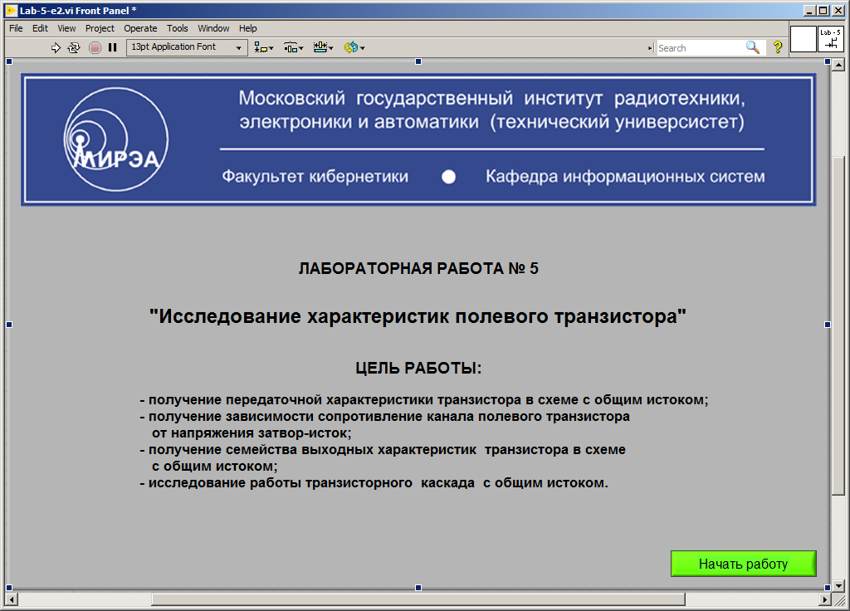

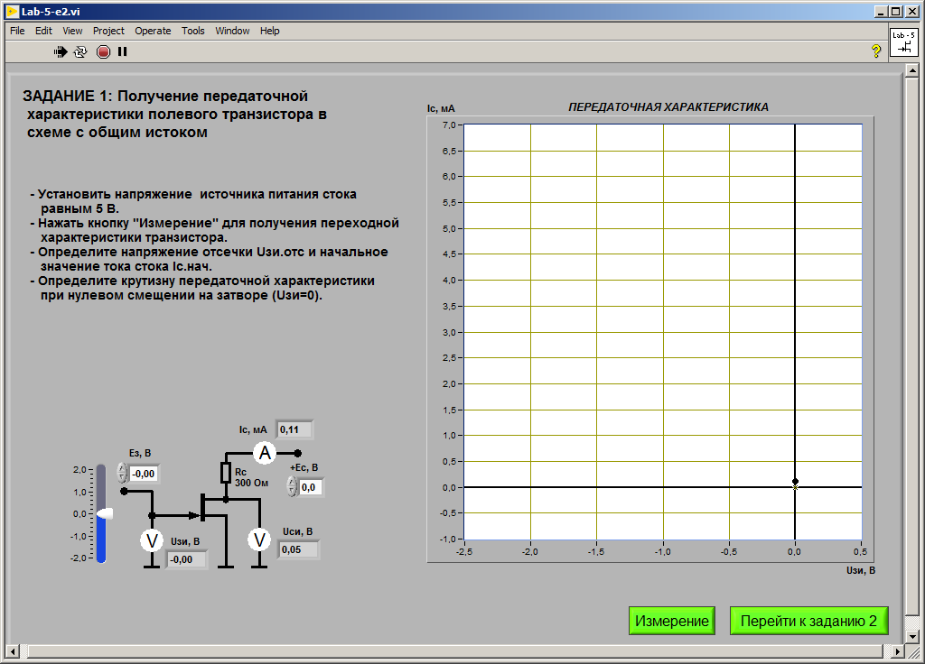

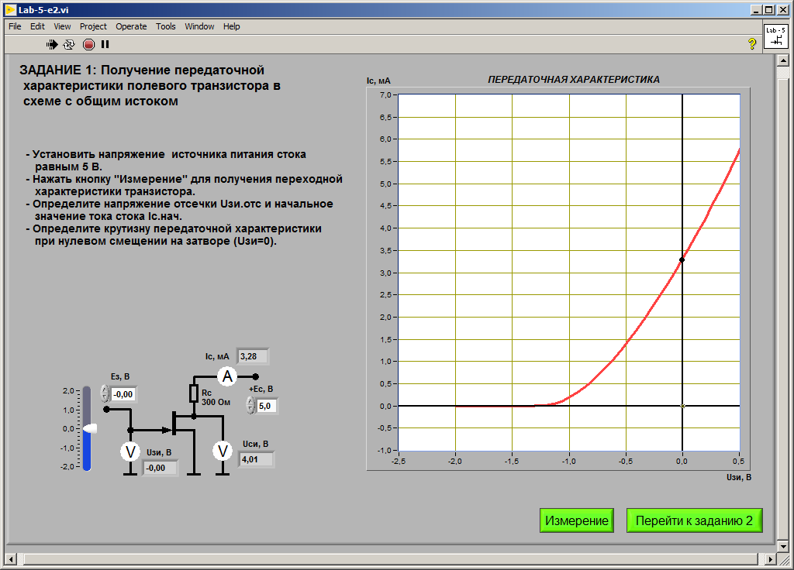

TUT values need to get

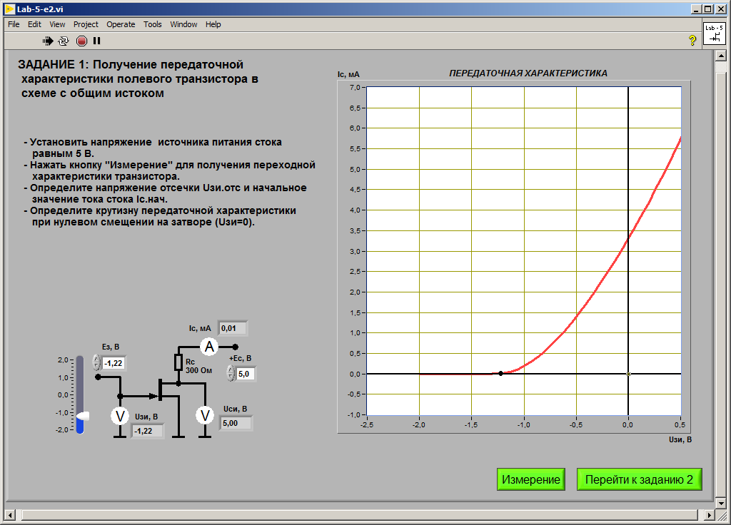

VALUES:

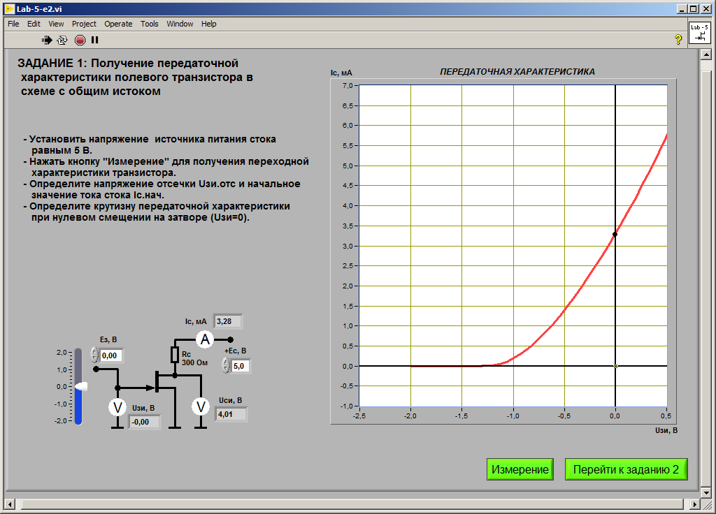

k = Ic / (U3u)^2 = 2,2

Ic1 = 2.85 mA

Ic2 = 3.71 mA

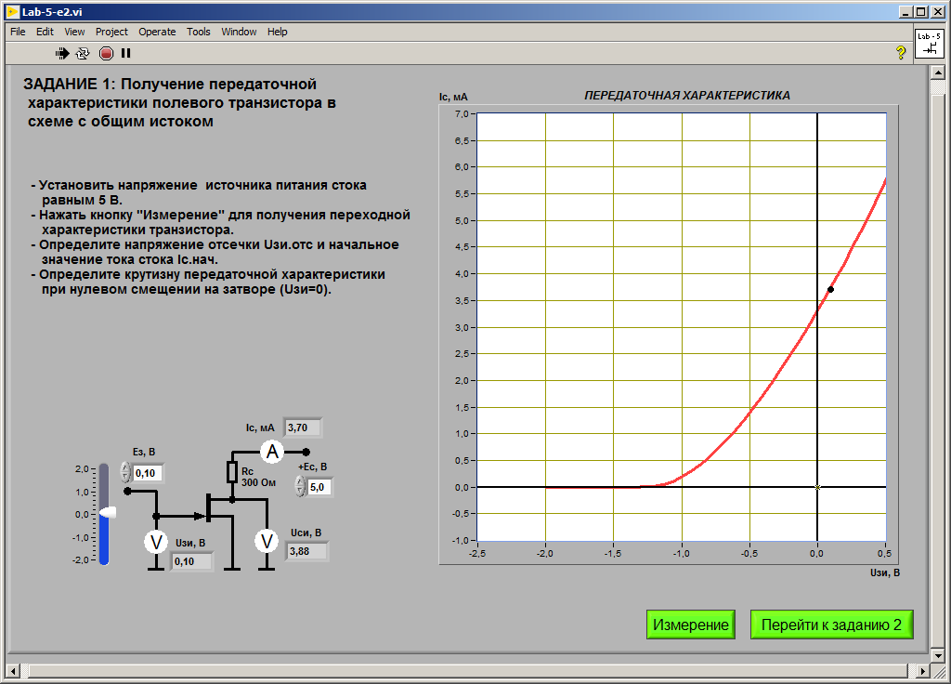

S = (Ic2 – Ic1)/(U3u2 – U3u1) = 4,3

TASK 2.

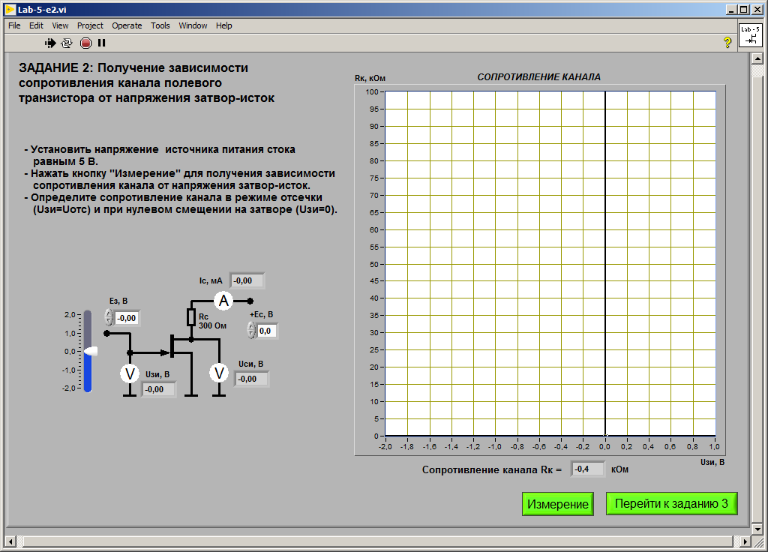

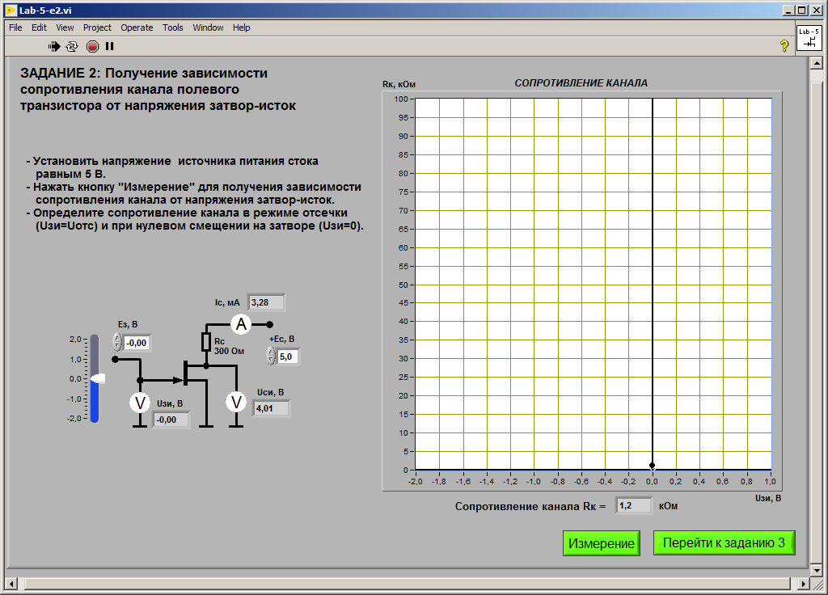

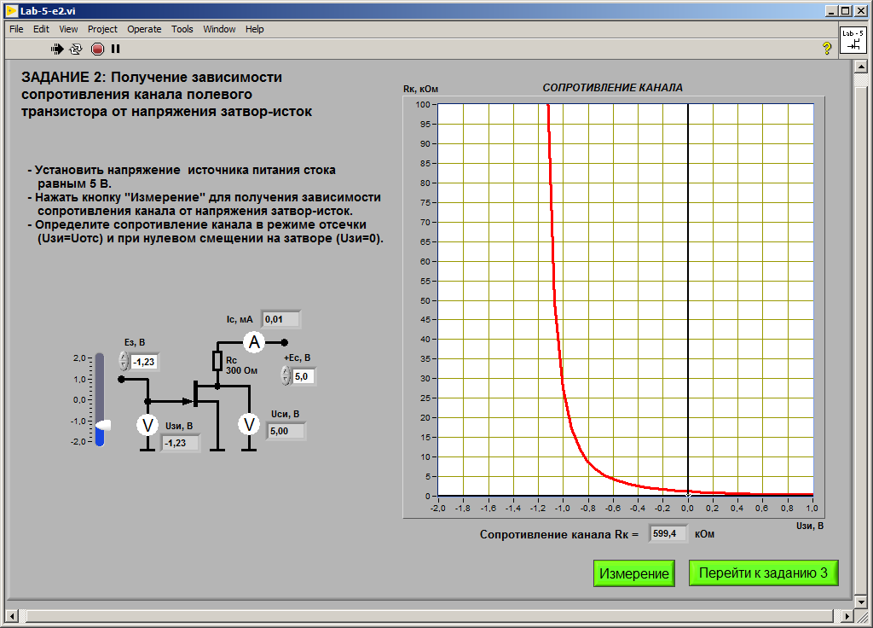

Rk max = 742,8kOm

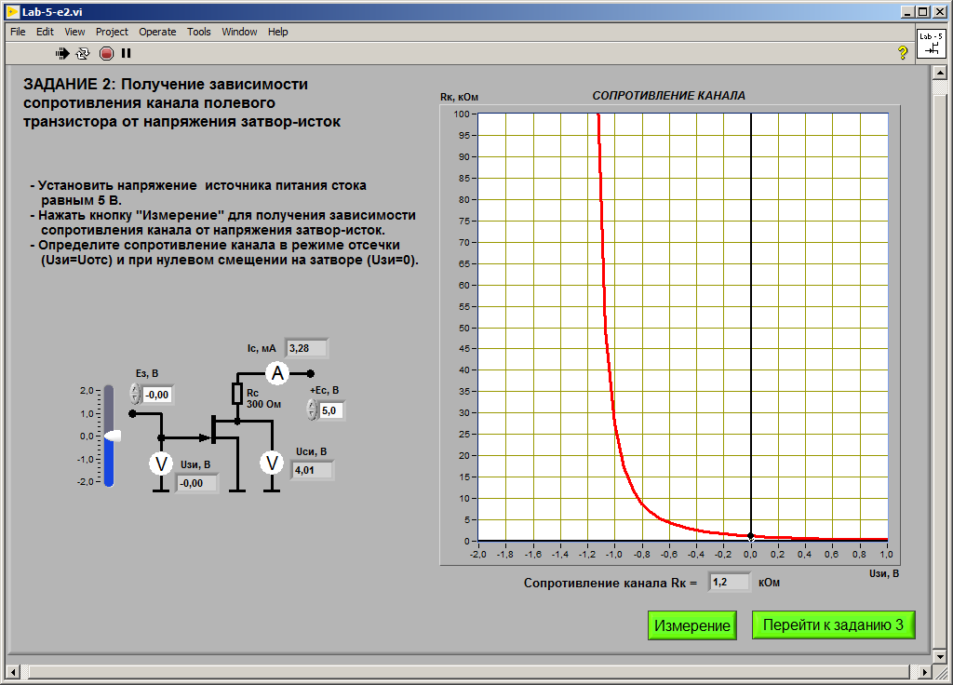

Rk min = 1,2kOm

TASK3

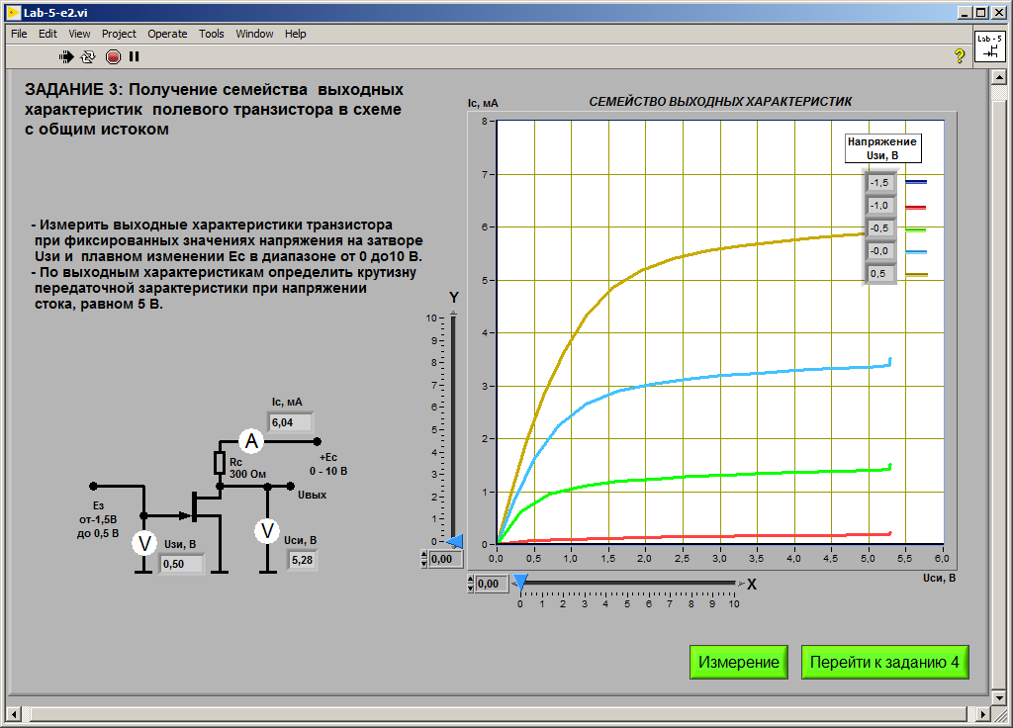

Edit in Paint lines

Ic:

Red 0.19 mA

Green 1.39

Blue 3,34

Orange 5.86

Dark blue 0

S = dIc / dU3u = (5.86 – 1.39/0.5 + 0.5) = 4.47 / 1000

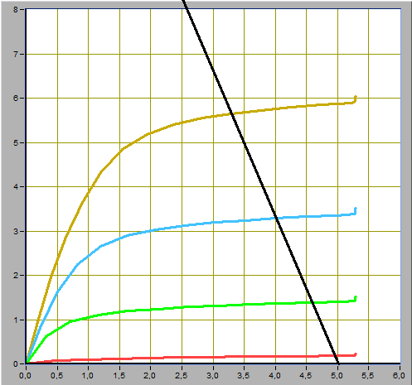

Ic max = 5.6 mA

Ic min = 0,2 mA

Ucu max = 4.9 V

Ucu min = 3.3 V

Ic* = (Ic max + Ic min) / 2 = 2.9 mA

S = 4.47, Ic* = 2.9 mA, Ic(blue) = 3,3 mA, U3u2 = 0

U3u*(1) = -0,098

TASK 4

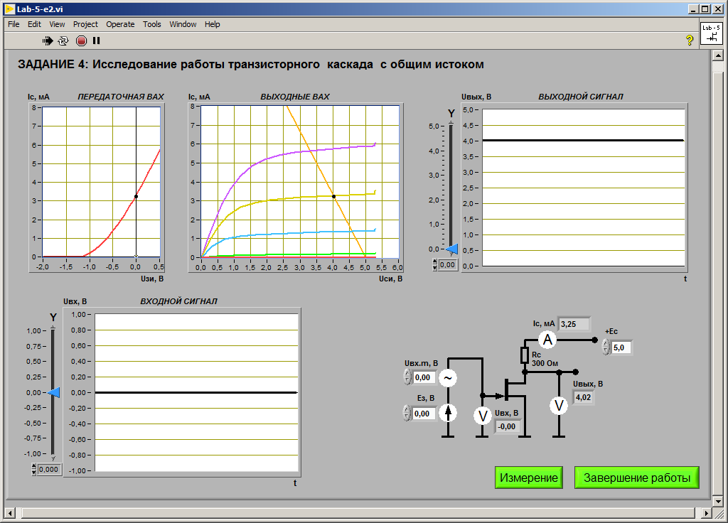

HERE is TABLE:

U3u = -0,098 V, Ic = 2,85 mA Ucu = 4,1 V

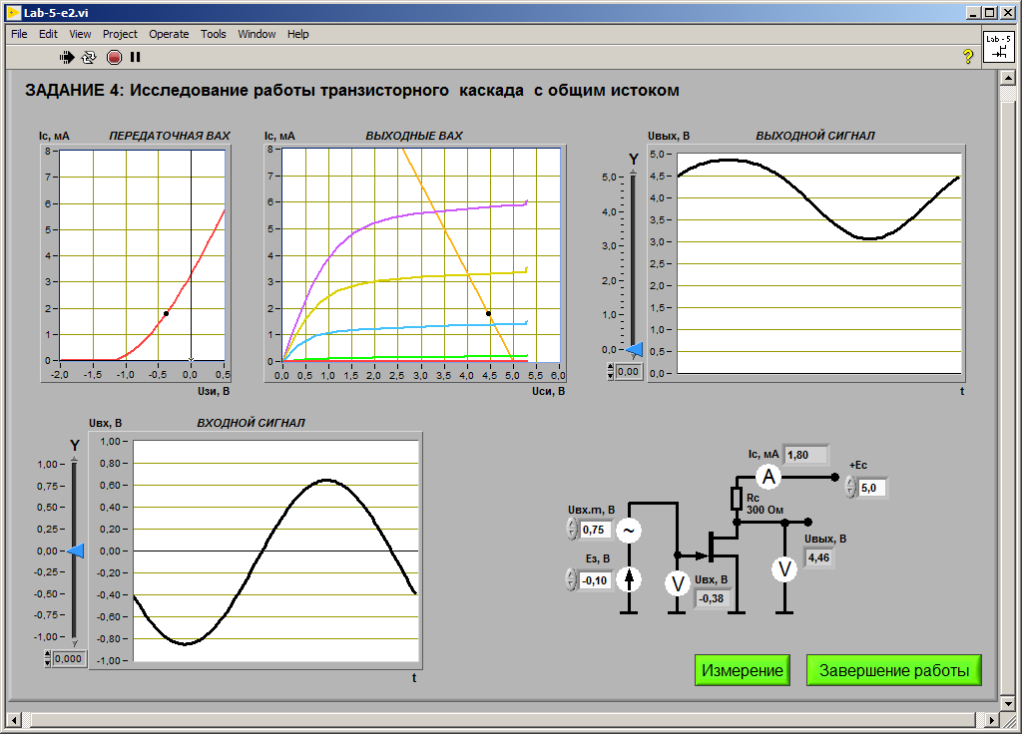

Vivod…. Protivofaza….

Uvx = (0.642 – (-0.841)) / 2 = 0,7415 V

Uvix = (4,88 – 3.06) / 2 = 0.91 V

Ky = Uvix / Uvx = 1.23

Ky = 4.47 * 300 Om / 1000 = 1,341

U3u* = -0,098

U3u*_1 = -0.69 -- minus 30%

U3u*_2 = -0,127 -- plus 30%

